Company______________________________________________
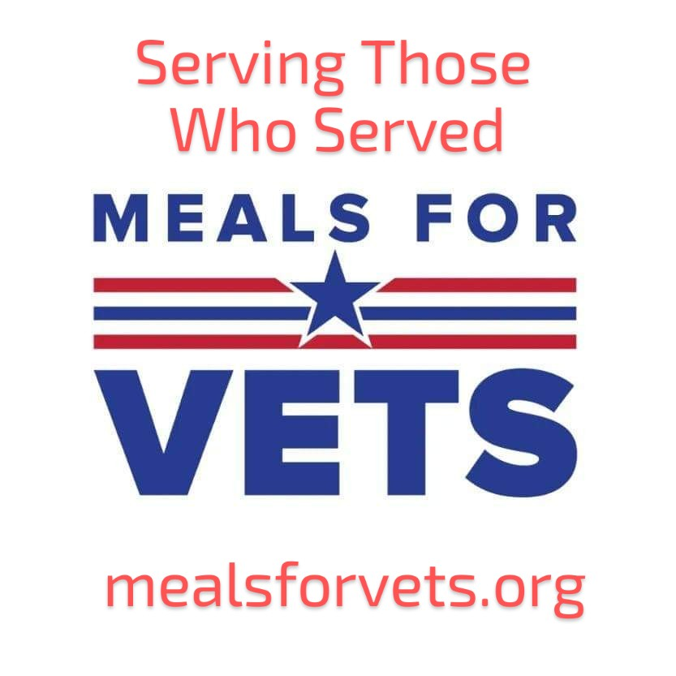
Contact Person___________________________
Phone Number____________________________
Address_________________________ City__________________ State ____ Zip_______
email__________________________________________________

I, _____________________, commit to providing the following items/services to Meals for Vets for their fundraiser on November 2nd, 2024:
________________________________________________________________________________________________________________________________________________________________________________________________________________________________________________________________________________________________________________________________________________________________________________________________________________________________________________________________________________________________________________________________________________________________________________________________________________________________________________________________________________________________
Services or supplies Meal for Vets needs to provide: (Labor, Electricity volt/amps, Water, Ice ECT)
____________________________________________________________________________________________________________________________________________________________________________________________________________________________________________________________________________________________________________________________________________________________________________________________________________________________________
If, for any reason, I cannot complete my commitment, I will notify Meals for Vets no later than September 30th, 2024.

Signature________________________________ Date____________________

