Company______________________________________________
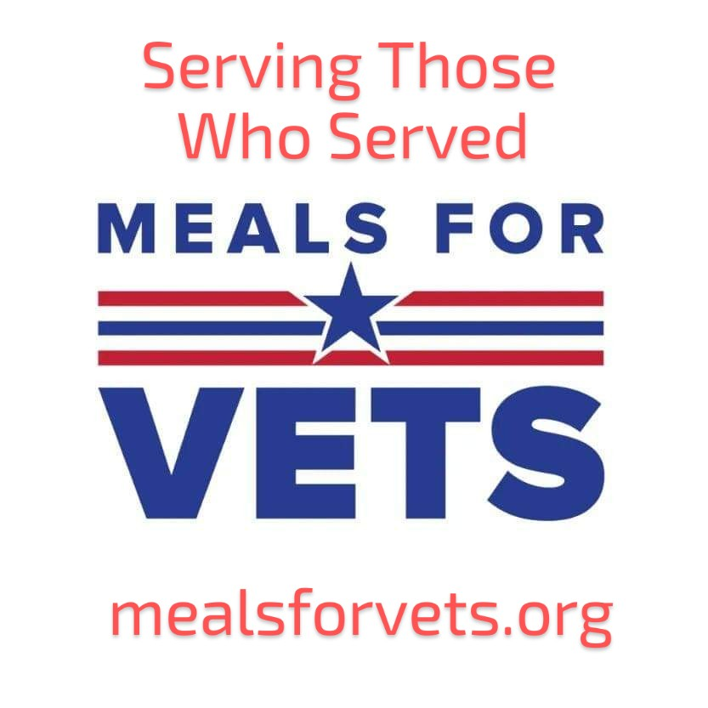
Contact Person___________________________
Phone Number____________________________
Address_________________________ City__________________ State ____ Zip_______
email__________________________________________________
Signature________________________________ Date____________________
Sponsorship Levels: (please check desired level)
$3000 PLATINUM VIP TABLE: seating for up to 8 people ~ includes up to 8 dinner tickets & up to 16 drinks, a banner with your company’s name & logo, recognition of your company on the radio, your company’s name & logo on all print and digital event advertising, special recognition during the event, and a Platinum level VIP gift basket with bonus raffle tickets.

$2000 GOLD VIP TABLE: seating for up to 8 people ~ includes up to 8 dinner tickets & up to 8 drinks, a banner with your company’s name & logo, recognition of your company on the radio, your company’s name & logo on all print and digital event advertising, and special recognition during the event, and a Gold level VIP gift basket.

$1000 SILVER VIP TABLE: seating for 6 ~ includes 6 dinner tickets & 6 drink tickets, name & logo recognition on all print and digital event advertising, also special recognition during the event.

$500 BRONZE: general seating ~ includes 2 dinner tickets & 2 drinks, name recognition on all print and digital event advertising.
$________ (value) In-Kind Donation: _______________________________________
$________ Other __________________________________________________
We would like to volunteer at the event and we’ll commit ____ volunteers. am___ or pm____

