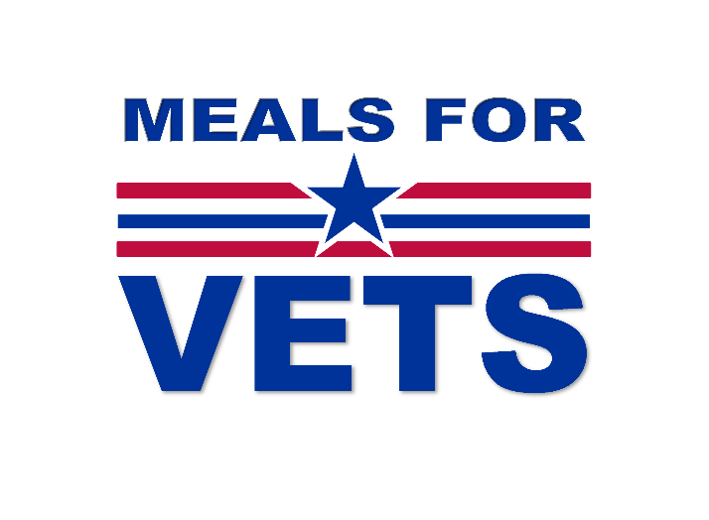 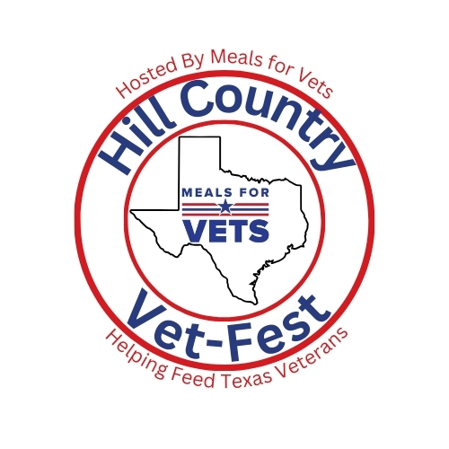

Dear Friend,

We are seeking your support for Hill Country Vet-Fest. Last year we were able to have over 60 raffle items to raise funds for Meals for Vets. With your help we can make this year even more successful and feed even more Texas Veterans and their family members who need help. In 2024 we paid for over 50,000 meals across Texas, and approximately 375,000 meals since we started.

Meals for Vets is in Fredericksburg, Texas, with a dedicated staff of Veteran and Veteran family members. We also have numerous enthusiastic volunteers who help us with our mission. Ninety-two percent of all funds donated go directly to the cost of meals, all other funds go to pay staff and overhead. This means your donation is helping Veterans statewide and brings revenue into the local economy and supporting local families and businesses.

Meals for Vets is a Veteran-founded 501(c) 3 non-profit with a unique mission…*Providing nutritious meals for hungry Texas Veterans, their families, and surviving spouses* *by funding the meals through contracted meal providers including over 40 colleges and universities*. Generally, our focus is 59 years and under, but we also fund meals for Veterans 60 years and over if they do not qualify for other programs (i.e., Meals on Wheels), or are on a waiting list, or live outside a local meal provider’s service area.

If you have any questions about sponsorship, please give us a call at (830) 992-3375.

Thank you for considering sponsoring Meals for Vets’ Second Annual Fundraiser!

Melinda Froess

Executive Director

EIN: 47-4994310

UEI: XPR7NNL8MUG5