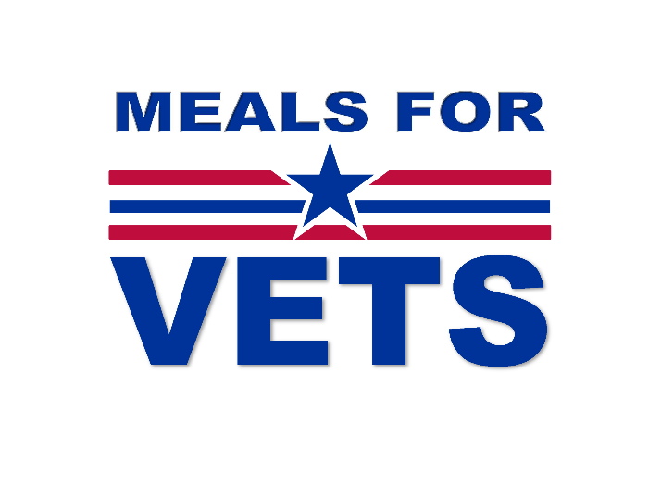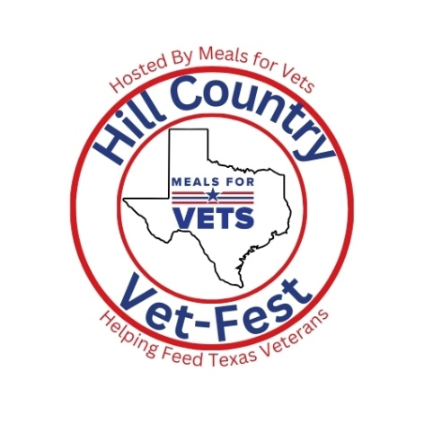
Dear Friend,
We invite you to partner with us in making Hill Country Vet-Fest even more impactful this year. Thanks to generous sponsors like you, last year’s event featured more than 100 raffle items, raising critical funds for Meals for Vets. With your support, we can exceed that success and provide life-changing assistance to even more Veterans and their families across Texas. In 2025 alone, Meals for Vets funded more than 57,000 meals statewide, bringing our total to over 432,000 meals served since our founding. Each meal represents dignity, stability, and hope for a Veteran and their family who served our country and now needs our support.
Based in Fredericksburg, Texas, Meals for Vets is a Veteran-founded 501(c)(3) nonprofit powered by a dedicated team of Veterans, Veteran family members, and volunteers. Out of every dollar donated, 92% goes directly to the cost of meals with the remainder supporting essential staff and operations. Your sponsorship not only feeds Veterans statewide, but it also strengthens local economies by supporting Texas families, businesses, and contracted meal providers. Your sponsorship of Hill Country Vet-Fest is more than a donation—it’s a visible commitment to honoring their military service and supporting those who have given so much. We would be honored to recognize your partnership as part of this meaningful community event. If you have any questions or would like to discuss sponsorship opportunities, please contact us at (830) 992-3375. Thank you for your sponsorship of Meals for Vets’ Third Annual Fundraiser.
With gratitude,
Meals for Vets

Melinda Froess
Executive Director
EIN: 47-4994310
UEI: XPR7NNL8MUG5

